Mutual inspiration in the development of new technology for older people

R. Eisma¹, A. Dickinson¹, J. Goodman², O.Mival³, A. Syme¹, L.Tiwari⁴
reisma@computing.dundee.ac.uk
1: Dept. of Applied Computing, University of Dundee
2: Dept. of Computing Science, University of Glasgow
3: HCI group, Dept. of Computing, Napier University, Edinburgh
4: ICCAVE, University of Abertay, Dundee

Abstract
There are few guidelines on how to involve older people in the design process of new IT related products. In this paper we describe some of the difficulties encountered when working with older people, and introduce the concept of mutual inspiration, illustrated by our experiences. We argue that mutual inspiration can provide a way to make interactions with older people more effective, leading towards more active involvement in the development process and more innovative results.

Introduction
The population of the developed world is getting older. In Scotland in 1960 the over 60s constituted 15% of the population; by 2025 this proportion will increase to 29% [GROS population estimates 2001]. In addition, fewer older people live with their children than did in the past, more people now live alone or with similarly-aged spouses [Grundy, 1996]. As Information and Communication Technology is expected to play an important role in enabling older people to live independently for longer and in supporting their communication needs, it is important to ensure that general technology products are usable by this age group as well as to develop products specifically targeting the older population.
Although most people agree on the importance of involving older people during the development of new technology [Keates and Clarkson, 2002], there are relatively few examples or guidelines for their successful involvement. Often traditional formats have to be adapted; various researchers report on the problems encountered when running focus groups with older people [Lines and Hone, 2002; Barret and Kirk, 2000]. There are some case studies about design processes involving older people [Ellis and Kurniawan, 2000; Gheerawo and Lebbon, 2000; Presence, 1999] which give valuable pointers as to how information can be elicited from this age group.
In this paper we describe a way of looking at interacting with older people intended to facilitate the development of better methodologies. We will first examine the problems of involving older people in the development process. We introduce the concept of ‘mutual inspiration’, illustrated by our experiences of the interaction between software developers and designers, and apply this to the interaction between technology developers and older people.
The research described is part of the UTOPIA (Usable Technology for Older People: Inclusive and Appropriate) project, a three-year SHEFC-funded consortium of four Scottish Universities (http://www.computing.dundee.ac.uk/projects/UTOPIA/) [Dickinson et al, 2002]. We are currently exploring various application areas and researching which issues are relevant to the development of products in those areas, including the development of methodologies that maximise the contribution of older people.

Older people in the development process

Older people
Older people are as diverse as the younger population, indeed, more diverse in their range of abilities. This diversity of ability exists not only within groups, but also for individuals: one person’s abilities can vary widely though time depending on factors like fatigue and illness [Gregor et al, 2002]. It is thus impossible to draw up a simple profile, or to identify a single stereotypical user. However, although the only common factor in this group is age (and there is a full generation of age difference between a 64 and an 86 year old!) there are certain ways in which older people in general can differ from the typical younger developer or researcher.
Older people can be affected by a variety of major and minor sensory, physical and cognitive impairments, often in combination and gradually increasing. These have to be taken into account in any sort of interaction with them, affecting the choice of location, the group size and any (written or otherwise) materials used [Barret and Kirk, 2000].
Such impairments, however, are just one of the factors that play a role in developing for and with older people. Other characteristics that will determine the successful use of an application or product are more difficult to capture in design guidelines. These concern the context into which the new technology will have to fit. In order to design truly usable technology questions such as the following need to be considered: What does an older person need, like and want? What does she fear? What experience with, and attitude towards, technology does she have? What are her finances, her living arrangements and her social network? How does the technology fit in with the rest of her life? How is she going to hear of the new product? Will she be motivated to learn to use it? How will she learn? Who will support her? For these aspects (and to find out about other aspects) the contribution of older people to the design process is essential.

Older people vs Technology Developers
The typical researcher or developer finds it easier to design for someone like themselves rather than for people in a different stage of life who may very well have different needs, wants, priorities and expectations [Keates and Clarkson, 2002].
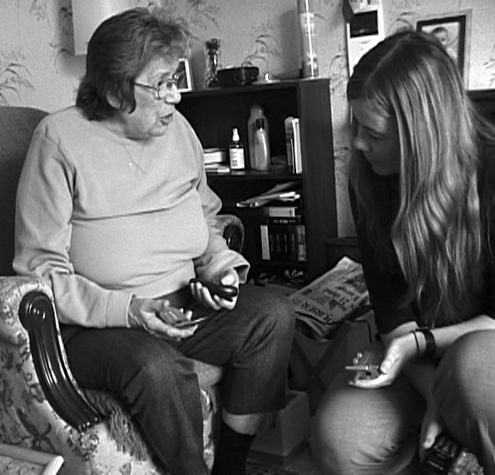
For example, developers may find it difficult to fully understand the impact of age-related impairments; knowledge of the existence of an impairment will not necessarily allow the developer to predict its detailed effects. For example, we talked to a woman in her late sixties who had had a stroke which resulted in some functional impairment. We discussed her use of her mobile phone (Phillips C12 Savvy) and then showed her a more modern, smaller one (Motorola v66). Contrary to our preconceptions she did not comment on the size of the buttons, instead she remarked that she liked a small phone which would fit in her pocket, as she could not use a handbag (it slides down her paralysed shoulder).

Figure 1: Older woman comparing two mobile phones

This cultural and experiential gap is especially large when developing IT products and other new technology. Discussing subjects that are part of everyday life for most people like housing is easier than discussing modern technology and computers, where enormous changes have taken place over the last few decades and the participant and the developer can have very different experiences. Many older people have had little exposure to computers, while for younger people (especially those who develop new technology!) much technology is an integrated part of their lives and they find it difficult to imagine life without it. A colleague in web accessibility commented in surprise that his grandfather had asked what the text on the television screen was that started “www”. People who are accustomed to older technologies may not be aware of the possibilities of new technologies which severely limits their ability to contribute to a discussion concerning them. It is generally recognised that apart from a few visionaries most people are unable to imagine technical options outside their own experiences. Such a culture gap can lead to the situation where developers come up with products based on their interpretation of the older person’s needs - a solution which is less than ideal and potentially patronising.
There are language and cultural differences which may make communication between younger and older people difficult. Older people, in our experience, can be reluctant to complain, or criticise products. Words may have different meanings for different age groups, and especially technical terms which may seem like normal words to younger people (‘monitor’ or ‘windows’) can be difficult to avoid or to describe. When asked about ‘technology’ very few of the people we spoke to could name examples, even while they just had been discussing older technologies like phones and televisions.
Older people can experience more computer anxiety, and be more negative about the amount of effort required to learn to use them, often fuelled by the assumption that they have no use for them [Marquie et al, 2002]. Some of the older people we have interviewed have entrenched beliefs about their inability to operate new technology. During a home visit a woman demonstrated her use of television-based email (which involved using a keyboard and mouse) but, when asked about using a computer, responded that she could never use a PC. This discomfort about computers and other technology is likely to affect the contribution that this person makes to the design process if these issues are not recognised and resolved.

Concept of Mutual Inspiration
The need to collaborate with people with different backgrounds and skills, wishing to draw on each others’ strengths, reminds us of our experiences with collaboration between software developers and designers in industry-based projects. In some of these projects a real cooperation never came into existence, and the end result was heavily dominated by one of the parties, without fully realising the strengths of the other party. In extreme cases this could mean a database-driven website with a thin layer of design covering an interface that mainly reflected the underlying technical structure, or a website looking like a print brochure without implementing the interactive possibilities of the medium.
However, occasionally such a collaboration produced results that surprised both parties, inspiring both to create something they would have been unable to do independently. In our experience, inspiration comes from questions and suggestions, from learning how and why the other person makes choices in their area of expertise, from discovering the possibilities presented by the other discipline. The creative process often follows an iterative route, with each person contributing in turn.
One of the conditions for achieving mutual inspiration is early involvement. Both parties should be involved in the initial requirement generation and prototype stages of the project. This can prevent the emergence of the research/design divide that often threatens the effective communication of requirements to the design team [Mival 2002]. With co-operation between designers and developers from the earliest stages, both sides know about all the criteria that shape the project, and both may influence early design choices.
It is equally important to have common ground, where both partners understand some of the other’s field, and where dialogue may take place. To establish this common ground each party has to be willing and able to talk about their expertise in language comprehensible to the other party. To profit from such communication both have to be prepared to consider challenging suggestions, and respect the other’s contribution and expertise.

In the development of new technology for older people we want a similar mutual inspiration to happen: we want to inspire people to give us answers to questions we are not asking, and to ask us for solutions and functionality we had not thought of, which in turn will inspire us to develop innovative products that really can and will be used by older people.

Achieving Mutual Inspiration

Process
In our own interactions with older people we aim to create the conditions described in the previous section. We involve older people early in the development process, while we are in the process of developing concepts for new products and applications, before we get to the stage of usage scenarios or other more detailed plans. We wish to learn from them what issues are important to them in new products, and what parts of their life could be improved by technology. And, perhaps more importantly, when technology should not be introduced: when we asked an elderly woman about online shopping, she explained that her weekly visit to Tesco with her niece was an outing which she would not want to miss, which suggested that while certain products may be very beneficial to some people they may have an adverse effect on the lives of others.
One of the conditions for mutual inspiration is the attitude of the people involved. The right atmosphere can be created by explaining the design process to everybody involved, and the role of the different parties. Older people are sometimes too much in awe of the technical knowledge of the developers, and it is important to make them aware of their expertise, and how valuable their contribution is.
We work towards a common ground by ensuring that we do not just inspire ourselves by obtaining information from the participants. Inspiring the participants is as important as eliciting information and this is achieved through introducing them to new technologies in a variety of ways, discussing possibilities, and encouraging them to think about their current use of newer and older technology. In many of our initial contacts with groups of older people we administered a questionnaire about their use of various technologies. The discussions spawned by these questions often proved more valuable than the factual answers to the questions themselves [Goodman et al, 2003].
Anecdote 1: at a Family Learning Centre
A lady, in her 70's, attended a computer class with her friend. She immediately stated that she was not interested in learning to use the computer, she had "no use" for it and it would not serve a function for her.

I started talking about the different Utopia projects. She reacted to my description of every project very positively, wanting to get involved. When I told her the methods we would be using such as focus groups, hands on workshops, questionnaires, interviews, etc, she responded: "Yes, an exchange of information.. I have the experience of being an older person I can share with you and you have just told me about so many things I have never thought of before... we can both help one another".

After an hour, this die-hard "no computers for me" told me she was going to the learning flat next week to start on the computers "as I would need it for using the messaging type thing you were talking about”. I said to her "So, you're now interested?" Her friend said "That's because you've given her a reason".
For many of the participants a focusgroup or other activity is a pleasurable social event. We try to support that by providing refreshments and by providing time for social interaction, both among the participants and between participants and researchers. In our experience the enjoyment that people get from learning about new products and technologies is an important motivation to participate, and to participate again. This is especially true of the hands-on activities described in the next session.

Hands-on activities
We have positive experiences with hands-on sessions, where older people experience new technology. These often lead to spontaneous suggestions for improvements or for new products (“this would be great for exercise” while playing Samba de Amigo, a Dreamcast game involving Maracas with built-in sensors), but it also lays the foundation for later discussions. Something similar is noted by Inglis et al who, after passing PDAs round to older people as part of a user-centred design process for memory aids, commented on the responsiveness the participants showed to the new technology [Inglis et al, 2002]. They also report that younger, technically-aware users were able to ask for functionality, unlike the older generation which was less exposed to developments in technology. This supports the need to spend time to transfer knowledge to the users involved in the design process to enable them to contribute.
Older people’s opinion on, and attitude towards, technology are often based on a limited number of experiences, either personal or stories from friends or relatives, and information gathered through the media. A hands-on experience can help to make them aware of some of the possibilities of technology, more than a verbal explanation or demonstration. At one of our workshops a woman who had had negative experiences at a computer class argued against the use of computers throughout the presentation and discussion of MSN Netmeeting but changed her attitude when using the system herself, playing noughts and crosses with her friend. This supports the work of Czaja and Lee who found that older people’s attitudes were changed positively after a positive computer experience [Czaja and Lee, 2003].

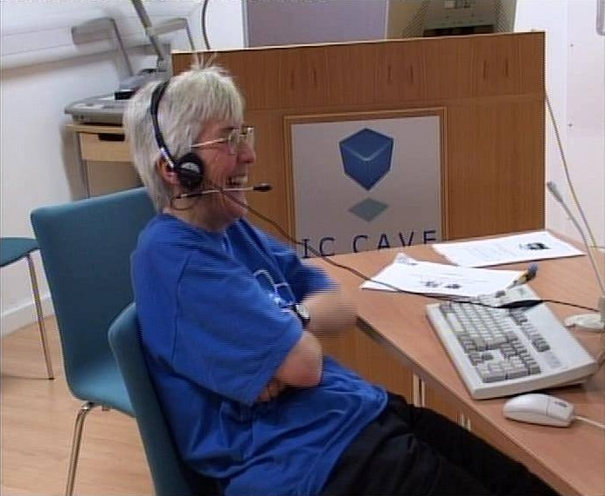
Figure 2: Enjoying her first experience with video conferencing
Another advantage of hands-on sessions is that they allow us to observe the difference between what people report and what actually happens. A number of people in a games workshop made it clear that they did not like games but were seen to be laughing and enjoying themselves. On other occasions people reported that they had no problems with an interface while difficulties could be observed during a practical session. For the researchers and developers involved it is extremely valuable to see people enjoy technology, or to see them struggle with aspects of it, and to get both their spontaneous reactions and first impressions as well as elicited opinions.
The hands-on sessions solve part of the language problem. Trying to describe an abstract concept like a chatroom in words (while avoiding any jargon) is much less effective than letting people experience it themselves.

Interaction with users can serve multiple purposes in a single session. We ran a workshop where 12 participants (with some computer experience) played a number of computer games. The direct purpose was to observe their interaction with unfamiliar software and a variety of interfaces, and their reactions to different styles of games, but it also served the purpose of introducing a group of people we hope to work with in the future to new concepts. How inspirational that can be for them was illustrated by the woman who, slightly breathless from excitement, stated that she never knew something like this existed. In future sessions these people will be better capable of discussing game elements in concepts for applications.

Discussion and Conclusions
The approach described is not intended as a new methodology but as a practical tool to improve existing methodologies and forms of interaction (for example focusgroups, questionnaires, presentations, interviews). It can be applied to every form of interaction with older people by checking, for example:
- how the purpose of the event and the role of the participants is explained
- what words are used to describe the design process and the technologies
- whether a hands-on element could be introduced to bring something to life
- what experiences might inspire the participants

A hands-on element could improve most interactions: for example, handing round a PDA during a presentation brings home the message better than words or images, while provoking reactions and stimulating discussions.
This approach is not only applicable to interactions with older people; however, they are most important with this user group because the gap between participants and facilitators is larger than in most other situations, as described earlier.
Elements of the described approach can be found in existing methodologies. In the Participatory Design case study described by Ellis, one of the first steps was to create a ‘bridge’ between facilitators and participants to improve communication [Ellis and Kurniawan, 2000]. However, what we describe is more general and can be applied in smaller scale interactions without entering a full PD process. In Gheerawo and Lebbon a process called ‘empathic bonding’ is described, which stimulates creative thinking and user-facilitated innovation. In this process most of the distance towards a common ground is covered by the designers who try to fully understand the user’s life and are inspired by that experience, but less attention is given to inspiring the users themselves [Gheerawo and Lebbon].
Though we are still in the early phases of our projects we found that by taking steps to create a common ground between developers and older people they became more actively involved in the development process, and communication became more effective. This involvement and communication opened the way for surprising answers from these users.

References
Barrett, J, Kirk, S (2000). Running focus groups with elderly and disabled elderly participants. Aplied Ergonomics 31, pp. 621-629

Czaja, SJ and Lee, CC (2003). Designing Computer Systems for Older Adults. In The Human-Computer-Interaction Handbook, ed. Jacko, JA and Sears, A. Mahwah, New Jersey. Chapter 21, 413-427

Darin Ellis, R, Kurniawan, Sri H (2000). Increasing the Usability of Online Information for Older Users: A case Study in Participatory Design. International Journal of Human-Computer Interaction, 12(2)

Dickinson, A, Eisma, R, Syme, A, Gregor, P (2002). UTOPIA. Usable Technology for Older People: Inclusive and Appropriate. Paper presented at A New Research Agenda for Older Adults, BCS HCI, London, 2002

General Register Office for Scotland (2001). Population by sex and quinary age groups.

Gheeraw, RR, Lebbon, CS (2002). Inclusive Design – Developing Theory Through Practice. In Universal Access and Assistive Technology, ed. Keates, Langdon, Clarkson, Robinson. Springer-Verlag, London. pp. 43-52

Goodman, J, Syme, A, Eisma, R (2003). Age-old Question(naire)s. Paper presented at Include 2003 conference, London.

Gregor, P, Newell, AF, Zajicek, M (2002). Designing for Dynamic Diversity – interfaces for older people.In conference proceedings of Assets 2002, p 151-156

Grundy, Emily (1996). Population Review: (5) The population aged 60 and over. Population Trends no.84, Summer 1996, 14-20

Hofmeester K, De Charon, E. (ed.) (1999): Presence, New Media for Older People. Printed by Presence at the Netherlands Design Institute. Amsterdam

Inglis, E, Szymkowiak, A, Gregor, P, Newell, AF, Hine, N, Wilson, BA, Evans, J (2002). Issues Surrounding the User-centred Development of a New Interactive Memory Aid. In Universal Access and Assistive Technology, ed. Keates, Langdon, Clarkson, Robinson. Springer-Verlag, London. pp. 171-178

Keates, S, Clarkson, PJ (2002). Defining Design Exclusion. In Universal Access and Assistive Technology, ed. Keates, Langdon, Clarkson, Robinson. Springer-Verlag, London. pp. 13-22

Lines, L, Hone, KS (2002). Research Methods for Older Adults. Paper presented at A New Research Agenda for Older Adults, BCS HCI, London, 2002

Mival, O (2002) In Search of the Cybermuse: Supporting creative activity within product design. In conference proceedings of Creativity and Cognition 4, 2002, p46-49

