In Search of UTOPIA: Usable Technology for Older People, Inclusive and
Appropriate
20th April 2004, Edinburgh

"Will you still need IT when you're 64?" ran one of the proposed taglines for this event and, while a bit of a joke, this did express a serious point. Despite the rapid ageing of the population, many believe that older people just do not need or use computers. Yet, with the over 60s due to comprise 27% of the UK population by 2025 and with increasing numbers of technologically-literate older people, this is a viewpoint that no longer holds water. We need to consider how the needs and desires of this important group can be met in technology design.
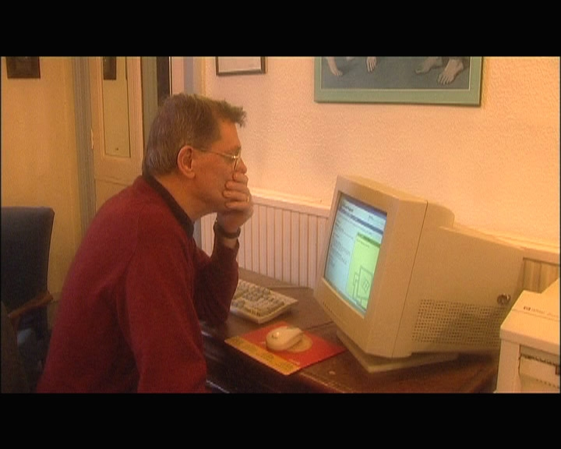
This workshop addressed these issues, discussing motivations, methods and user characteristics to consider when designing for this age group. Over 100 people attended the all-day workshop, which provided a rotating programme of concurrent sessions to allow delegates to pick-and-mix activities. It included a variety of formats, from talks and panel sessions to a video room and interactive workshops.

There isn’t room here to describe all of the talks, but a description of a few may give you a taster. Speakers included Dave Sloan and Lorna Gibson (Digital Media Access Group), talking about legislation and web accessibility. Particularly informative were their examples of website accessibility problems and their illustrations of how these sites would appear to someone with colour blindness or when viewed with a screen reader. Michael Smith (Fujitsu Consulting) talked about handling application complexity and Alex Carmichael (University of Dundee) discussed whether there is such a thing as an "average" user, tackling the issue of the variety in the older population.

Keynote talks looked at older people and ICT from the perspective of Scottish Power and the Scottish Executive's 21st Century Government unit, as well as from the perspective of an older person herself (more about this later).

Interactive workshops provided an opportunity to gain some experience of what it might be like to have failing sight, hearing and dexterity and to learn from this about how to communicate better to older people about unfamiliar technology. We learnt that apparently very clear visual aids can still be indecipherable and that the addition of clear verbal descriptions is very important. We also found that we often wrongly assume technical knowledge on the part of users - even the innocuous phrase "mobile phone" can cause difficulties for some.

Another workshop allowed participants the chance to design a product that considered older people's needs. Delegates were divided into small groups and given a brief to design a device to help families coordinate their activities and pass information around. A great range of ideas was produced, addressing issues such as security, aesthetics and entertainment. The needs of older people tended to be considered as part of an inclusive design, rather than a focus on their own.

Throughout the day, a series of videos was run, illustrating some of the difficulties that many older people have with technology. By displaying scenarios based on real experiences, these helped to make some of the issues come alive.
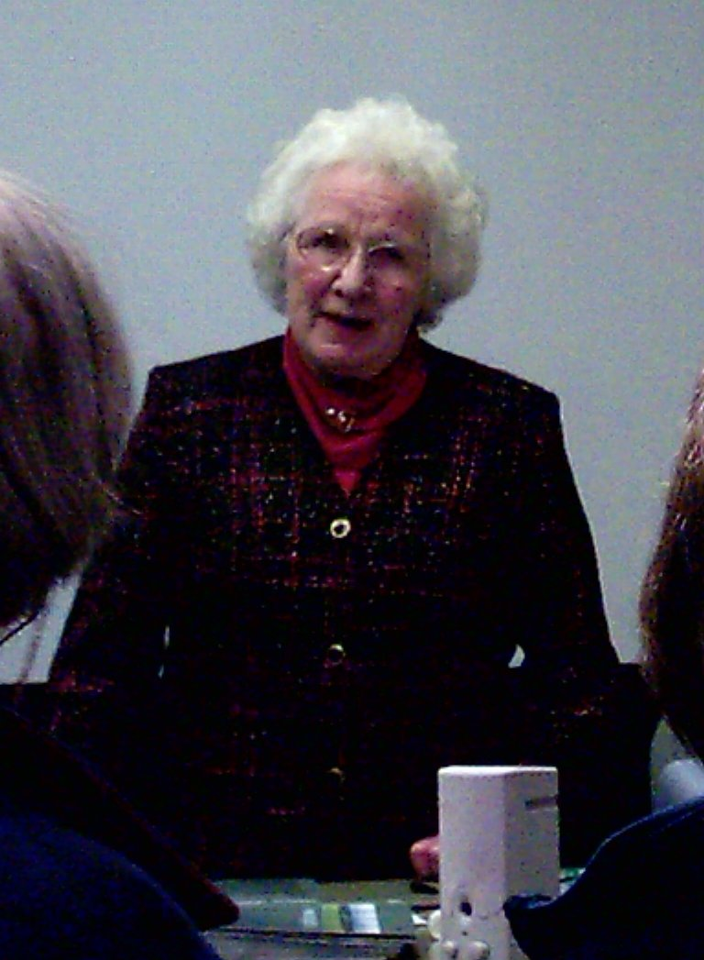
These sessions generated interest in a variety of issues discussed in the panel sessions. There was a consensus that we need to focus on users, tasks and incentives rather than on the technology and that designing for the older population is much more than just ticking a set of technical check-boxes. Delegates also discussed whether older people need special attention or whether we should simply be sensitive to special needs that older people may share. While conclusive answers were not always reached, interesting ideas and issues were raised.

The workshop finished with a fascinating talk from a representative of the older population, Mamie Bruce-Gardyne. She spoke about how she set up and runs a computer group in a rural Scottish area and challenged those who teach older people to consider the pace at which they go, the jargon that they use and, importantly, the attitude that they display towards these older learners.

All in all, the workshop proved to be a very productive day, challenging preconceptions about the older popuation and encouraging the participants to consider older people in design.

Footnote: The workshop was organised by the UTOPIA project, funded by SHEFC. It was supported by BCS HCI.

Author: Joy Goodman

