Personalised and Adaptive Multimedia Retrieval

Joemon M. Jose and Jana Urban

Data accumulation is become an integral part of our life, be it text (e.g., email) or multimedia data (e.g., photographs). This is mainly due to the proliferation of computers, networking devices, and also consumer devices like digital cameras and camcorders. However, our creation prowess is not matched by any comparable search facilities. As a result, finding relevant information from such archives become a cumbersome process. Even after a decade long research in content-based image retrieval (CBIR), users have to plough manually through their media archives in order to find what they are looking for.

There are a number of reasons for this scenario. The major one is that the state of the art in image processing does not allow us to identify and extract any meaningful segments from images. Images are still represented using low-level features. However, the images’ low-level feature representation does not reflect the high-level concepts the user has in mind (semantic gap) and – partially due to this – the user tends to have major difficulties in formulating and communicating their information need effectively (query formulation problem).

Any reasonable solution to CBIR should address the issue of semantic gap. One way to address is to provide help in query formulation. In our approach to image retrieval, we employ an adaptive scheme for image retrieval.

Adaptive Models for Image Retrieval

Query formulation difficulty is addressed using an adaptive query learning scheme and an innovative search interface. We have developed an interface (Figure 1.) in which a user starts browsing with one example image. Subsequently, a new set of similar images are presented to the user.

As a next step, the user – through selecting one of the returned images – updates the query, which now consists of the original image and the selected image from the returned set of images. After a couple of iterations the query is based on a set of images. In this scheme, the retrieval process is iterative: updating the system’s knowledge of the user’ information need based on the user’s implicit feedback. In the underlying interaction model the user builds up a browsing tree of interesting images by choosing one image from a recommended set to be appended to the browsing path in each iteration. The system’s recommendations are based on query constructed from the current path of images.

In this approach, the emphasis is placed on the user’s activity and the context, rather than predefined internal representation of the data. A path represents a user’s motion through information, and taken as a whole is used to build up a representation of the instantaneous information need.

In a nutshell, it supports both browse-based and query-based approaches. It supports a query-less interface, in which the user’s indication of the relevance of an image – by selecting an image – is interpreted as evidence of being relevant to his current information need. Therefore it allows direct searching without the need for formally describing the information need. For the query, each image in the path is considered relevant, but the degree of relevance is dependent on the age: it decreases over time when new images are appended. In this way, the retrieval model is a special kind of relevance feedback model, in which a query is refined by the user implicitly selecting images for feedback. It recognises and addresses the issue of changing information needs (dynamic nature of information needs), and has the advantage of allowing for an intuitive and user-centred search process.

Figure 1 shows an interface of the system.

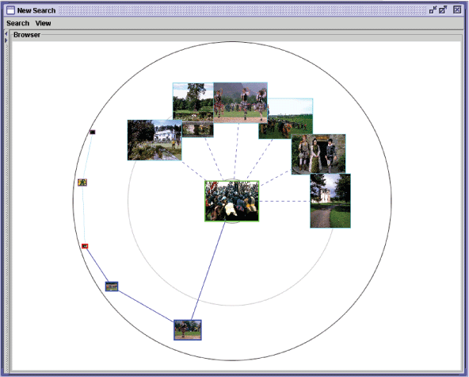

A user study involving design students demonstrated the effectiveness of this approach. The evaluation showed that people preferred the search process in the ostensive browsing scheme, felt more comfortable during the interaction, and found the system more satisfactory to use compared to a traditional CBIR interface.

Image Retrieval by Group Organisation

Another approach to provide effective image retrieval solution is to develop mechanisms to support the handling of the retrieved set of images. This will allow users to handle retrieved set of images better by organising them into relevant groups. This will allow the system to capture the context of the user, thus will be able to recommend images more tuned to their need.
We introduced a system called EGO (Effective Group Organisation) which facilitates retrieval in context (Figure 2). EGO is a system for the management of image collections, supporting the user through the personalisation and adaptation. In this system, we stress the need for a search system, which provides flexible and extensible interfaces. The idea is to help the user in query formulation. By facilitating qualitatively high interaction, system learns user needs and provide search

Our approach encourages the user to group and organise their search results and thus provide more fine-grained feedback for the system. It combines the search and management process, which helps the user to conceptualise their search tasks and to overcome the query formulation problem. The system assists the user by recommending relevant images for selected groups. This way, the user can concentrate on solving specific tasks rather than having to think about how to create a good query in accordance with the retrieval mechanism.

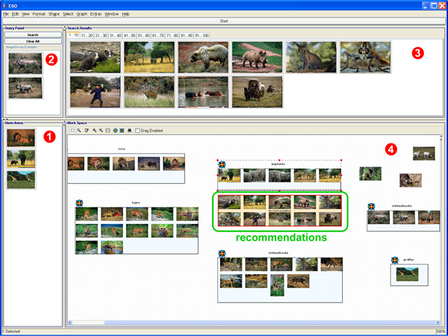

Figure 2. EGO Interface

Contact
Dr Joemon M Jose, Dept of Computing Science, University of Glasgow, Glasgow G12 8QQ

