Algorithmic Foundations 2

Assessed Exercise 2

Notes for guidance:
- This is the second assessed exercise for the Algorithmic Foundations 2 module and is worth 10% of your final grade.
- Hand in a paper copy of your answers - these need not be word-processed; however hand written answers must be legible. Important: you must write your name, matriculation number, and lab group at the top of your script. Without this information you risk gaining no credit for your answers.
- The deadline for completing this assessed exercise is Thursday 18th March at 4.30pm - note that this is a strict deadline.
- Completed exercises must be posted in the appropriate pigeonholes and you must attach a completed "Declaration of Originality" form (the pink form) to your submission

Questions

- A company has a contract to cover the four walls, ceiling, and floor of a vehicle assembly building with fire-retardant material. The building is 280m wide, 168m high, and 336m wide. Square panels can be manufactured in any size of whole metres. For safety reasons, the building must be covered in complete panels (i.e. panels cannot be cut). What is the minimum number of equally sized square panels that are required to line the interior of the building? Explain your answer.

- Prove that the square of an even integer ends in 0, 4, or 6.
- Using the principle of mathematical induction prove that $\sum_{k=1}^{n}{k^{2}}=\frac{n(n+1)(2n+1)}{6}$ when $n≥1$.

- Use the Principle of Mathematical Induction to prove that $2|(n^{2}−n)$ for all $n≥0$.

- Each type of machine part made in a factory is stamped with a code of the form "letter-digit-digit". Prove that if 3000 parts are made then at least two must have the same code stamped on them.

- A certain type of push-button door lock requires that you enter a code before the lock will open. The lock has five buttons, numbered 1, 2, 3, 4, 5.

- You are allowed to choose an entry code that consists of a sequence of 4 digits, with repeated numbers allowed. How many such entry codes are possible? Explain your reasoning
- You are allowed to choose an entry code that consists of a sequence of 3 or 4 digits, with no repeated digits allowed. How many such entry codes can there be? Explain your answer.

- The following arguments are incorrect, i.e. they are fallacies. Explain why they are fallacies.

- A sports car is fun to drive. Patrick's car is not a sports car. Therefore Patrick's car is not fun to drive
- Zoë likes comedies. Zoë likes the Matrix. Therefore the Matrix is a comedy.

- An automated guided vehicle (agv) is currently at position A in the picture below, and must travel to position B. The agv is only allowed to move on the grid lines, and can only make a move in one time step either to the right one position or up one position. The agv has to reach point B in 13 time steps. How many different trajectories can it have getting from A to B? Explain your answer.

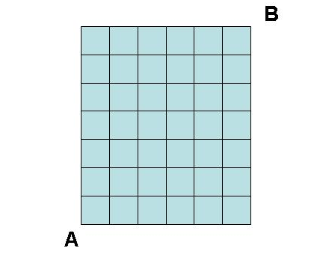

9. Define the java function perm below, where perm takes as argument a string and prints out all permutations of that string.
