MSc IT Course

Outlook – a Minimal Guide for IT

You should read your e-mail regularly; it is the primary means of communication within the Department.

The application that you will use to send and receive e-mail is Microsoft Outlook. This is a complex application that can do far more than send and receive email. These instructions are merely to get you started. You should use the online Help facilities and experiment in order to become a competent Outlook User.

Opening the application
Outlook is represented by a shortcut on the XP desktop, and may be launched by double-clicking that icon (or via Start→Programs). It is possible that the first time you open Outlook you may have to deal with a number of ‘error message’ dialog boxes. Just click on OK or YES as appropriate – the dialog boxes should not display on subsequent occasions.

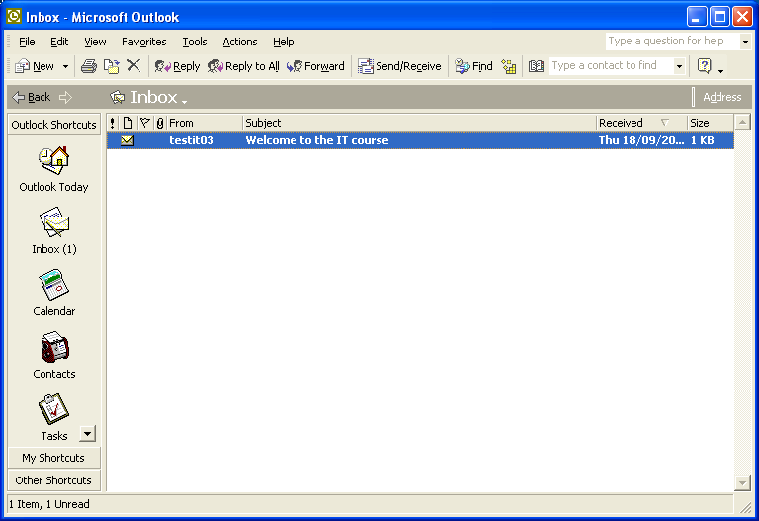 | You should see a window as shown on the left. The left hand pane contains shortcut icons to folders (see below). The top pane contains a toolbar giving quick access to frequently used commands. All commands can be accessed via the menus. The main pane shows a list of your mail messages. You can decide if you want to see previews of your mail, using the View menu

Folders
Outlook organises your work into a number of folders. For email the relevant folders provided are:
- INBOX: all incoming messages are stored here
- DELETED ITEMS: messages that you mark for deletion are stored here until you decide to empty this folder, at which point the deleted messages disappear.
- DRAFTS: you can store incomplete mail messages here
- OUTBOX: messages that don’t get sent for whatever reason are stored here
- SENT ITEMS: copies of all messages you have sent are stored here. They are not editable.
You can also create your own folders (use menu item File->New Folder). A good place to create folders is inside the INBOX folder. You can then transfer messages you want to keep to relevant folders, rather than clutter up the top level of the INBOX with hundreds of old messages.

Shortcuts
You access the Outlook folders and your own folders by double clicking Shortcut icons in a pane on the left of the main Outlook window. The Shortcut icons are divided into three groups. The groups are accessed via buttons, also in the left hand pane. The groups are:
- Outlook Shortcuts: contains the INBOX and DELETED ITEMS icons
- My Shortcuts: contains the shortcuts to the remaining folders mentioned above and also shortcuts to any folders you create for yourself
- Other Shortcuts: contains shortcuts to ‘System’ places such as the My Computer explorer window.

Reading mail
To read new mail, open your INBOX, and double-click on any message you wish to read. Unread messages (new messages) will be marked with a ‘closed envelope’ After reading a message, you can close it but leave it in your INBOX (just close the message window), transfer it to another folder (see above), delete the message (Delete icon on the toolbar), reply to it (Reply icon on the toolbar), etc.

Sending mail
To send a message, choose New. This opens a version of Microsoft Word with some special commands available. Fill in the email address of the recipient, the subject field, and type the body of the message below the line. Click Send when ready. When you close your message, you are returned to the main Outlook window. To send mail to your fellow students you need only give the username; to send mail to staff and other members of the department or outside the department, you need the full e-mail address. The full email address for staff and postgraduate students in the Computing Science Department is <user_name>@dcs.gla.ac.uk.

Outlook help
Outlook has many other facilities and options. The on-line help may be used to explore these.

Using Webmail
You can read your departmental email and send mail from anywhere as long as you are connected to the internet. Open your browser and access the URL https://owa1.dcs.gla.ac.uk/exchange. You will be asked for your user name and password.

