MSc IT Programming – Lab 7

Description of Problem

Your program will draw a series of boxes made out of letters in its own Console window. It will look like this:

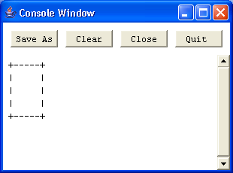

This box has 5 rows and 7 columns. This information is obtained from the user from another Console window, the dialog looking like this:

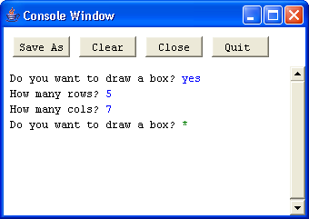

Note that the user is repeatedly asked if they want to draw a box, until they answer no. They may generate several different boxes, each in its own Console window. You should use several helper method to do the drawing.

Exercise 1

Write a helper method called drawTop that draws the top and bottom of the box. It will draw a +, a sequence of -, and then a +. It will need a Console and the number of columns as inputs. It does not return any outputs. Test this program by calling it from main. main should create the Console and provide the number of columns. You do not have to get any information from the user at this stage. You can just hard code the number of columns in main.

Now write a helper method called drawSide to draw both sides of the box. Once again test it by calling it from main.

Exercise 2

Write a helper method called drawBox to draw a box in a separate Console window. It should create the Console object and use drawTop and drawSide to do the drawing. Test it to make sure it works. Add in the user interaction so that the user can draw a series of boxes.

There are a number of special cases to consider. Produce some sample data for the happy day scenario and also test data for other cases.

Exercise 3 (Extension)

You may have noticed that drawTop and drawSide are very similar helper method. Replace them with a single method called drawRow that is able to do the work of both drawTop and drawSide. Hint: it will need two extra inputs.

