You should be able to get Images like these..

ONE

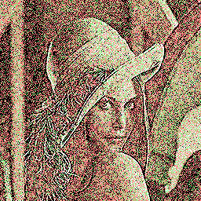

..produced with the specified palette 1 , 15 % noise

TWO

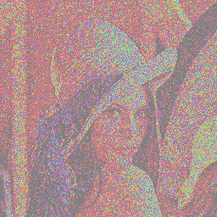

..produced with a palette of 4 colours (Red, Green, Blue, Mid- Grey)& 15% noise

THREE

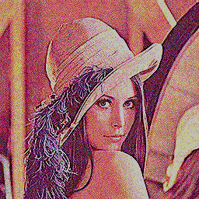

..produced from the 6 bit palette with 5% noise

