Compiler Page
Prev |  | Next

Vector Pascal: a free Pascal Compiler

Vector Pascal is a language targeted at SIMD instructionsets such as the MMX and the AMD 3d Now
It currently supports
the 486,
the AMD Opteron 64 bit processor,
the Pentium,
the Athlon
the Sony Playstation 3 Emotion Engine
the Intel P3 and P4 processors.
It supports parallel vector operations, loop unrolling, common sub expression removal.

. It is implemented in Java, and is available for download in source or binary.

Downloads
To download the latest binary version of Vector Pascal you should click on install.jar.
For a source version click on source release

Overview
Vector Pascal is an extended Pascal incorporating:
- Unicode support – New in version 4
o Programs may be input in Unicode, allowing Chinese, Greek, Japanese and Russian characters in variable names.
o Strings can contain Unicode.
o Characters are 16 bit.
o Conversion to and from UTF-8 performed on input and output.
o Mathematical operators √ , ∏, ∑, ≤, ≥, ∈, ÷ can now be entered in Unicode rather than as ASCII surrogates

- Vector Pascal extensions aimed at vector processing. These are derived from APL and similar to the extensions provided in Fortran90. These extensions translate to the SIMD instructions of the Athlon and P4 etc.
o All operators extended to arrays eg: a:=a +b where a,b:array[y] of t;
o All monadic functions map over arrays eg: p:=sin(q); where p,q:array[1..n] of real;
o TRANS transposes a matrix
o The reduction functional \ can perform array summation etc
o Array slices of the form A[ i..j]:= K[i+1..j+1]
o Read and write operate on multidimensional arrays

- New operator extensions
o User defined operators allowed
o Operators +: and -: perform saturated arithmetic
o MIN and MAX

- Type system extensions
o Type pixel predefined as fixed point number in range –1 .0 to 1.0
o Sets of strings, reals, etc allowed. – New in version 4
o Dimensioned reals allow distinct and incompatible types for time, distance, mass etc
o Generic Units allow the writing of polymorphic functions

- Many of the ISO Extended Pascal features in particular
o Schematic array types
o Extended formats of Pred and Succ
o Any type can be returned by a function
o Operators ** and POW for exponentiation and Power
o >< for set symmetric difference
o Complex numbers
o Protected parameters
o Sets of arbitrary cardinality
o For x in y do for set iteration

- Turbo Pascal features
o Units, Strings, Turbo Pascal style file operations
An overview article in .pdf format.
A comparison with other languages and implementation details are given in Vector Pascal an Array Language . A .pdf and a .ps version are also available.

Reference manual
.pdf version
postscript version
.html version, note that some formulae do not appear correctly in the html version.
The code generator technology used to retarget the compiler to different platforms is documented in: Direct compilation of high level languages to multi media instructionsets . Covers use of MMX, 3DNOW and SIMD instructions to obtain parallelism. Also available as HTML
SIMD Programming Manual for Linux
The book is a programming manual for SIMD processors with special emphasis on the use of Vector Pascal

Related Work
Similar vectorisation transformations for a C compiler have been done by Aart Bi k whose web page contains useful articles on vectorisation.

Speedups
Vector Pascal provides considerable speedups on vector loop based applications:
Table 1: Comparative Compiler Performances on Convolution
Program | Implementation | Target Processor | Million Ops Per Second
conv | Vector Pascal | Pentium + MMX | 61
 | Borland Pascal | 286 + 287 | 5.5
 | Delphi 4 | 486 | 86
 | DevPascal | 486 | 62
pconv | Vector Pascal | 486 | 80
 | Vector Pascal | Pentium + MMX | 817

Table 2: Pascal Compiler Performances in Million Ops per Second on vector kernels
TEST | DevP | TMT | BP 286 | DP 4 | VP 486 | VP K6
unsigned byte additions | 71 | 80 | 46 | 166 | 333 | 2329
saturated unsigned byte additions | 55 | 57 | 38 | 110 | 225 | 2329
32 bit integer additions | 85 | 59 | 47 | 285 | 349 | 635
16 bit integer additions | 66 | 74 | 39 | 124 | 367 | 1165
real additions | 47 | 10 | 33 | 250 | 367 | 582
pixel additions | 49 | 46 | 23 | 98 | 188 | 2330
pixel multiplications | 67 | 14 | 39 | 99 | 158 | 998
real dot product | 47 | 10 | 32 | 161 | 164 | 665
integer dot product | 79 | 58 | 33 | 440 | 517 | 465

Abbreviations DevP - Dev Pascal version 1.9, TMT - TMT Pascal version 3, BP 286 - Borland Pascal compiler with 287 instructions enabled range checks off., DP 4 - Delphiversion 4, VP 486 - Vector Pascal targeted at a 486 , VP K6 - Vector Pascal targeted at an AMD K6 . Measurements on a 1Ghz Athlon.

Development Environment
Vector Pascal now comes with the VIPER IDE , which supports:
Syntax highlighting
Project management
Compiling and linking
Automatic translation of Pascal to Tex using VPTEX

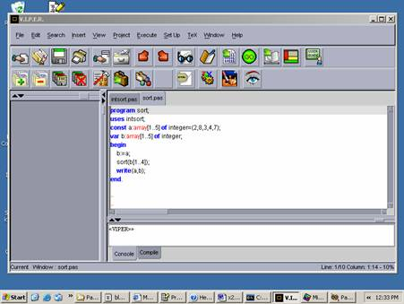

VPTeX
Both the command line and the IDE compilers contain the facility to translate Pascal to Latex to provide a literate programming environment. Comments can contain Latex which is passed to the latex output, pascal code is translated using a literate programming style.
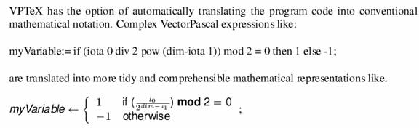

Dependencies

Releases
Latest binary release covering all systems is in install.jar
src.jar the most recent source package to be released

Previous releases:
The following are old Linux only releases
linstall4_6.jar linstallc1_81.jar linstall.jar
rtl.jar release of the runtime library on its own
src6.5.2002.jar old source release
Windows only releases
winstall1_59.jar winstallc1_81.jar ./winstall.jar

Keywords: Pascal, free Compiler, MMX, Vector, SSE, 3Dnow!,APL
hit counter button

Prev | Home | Next
Compiler Page | wpc@dcs.gla.ac.uk | Teaching exercises

